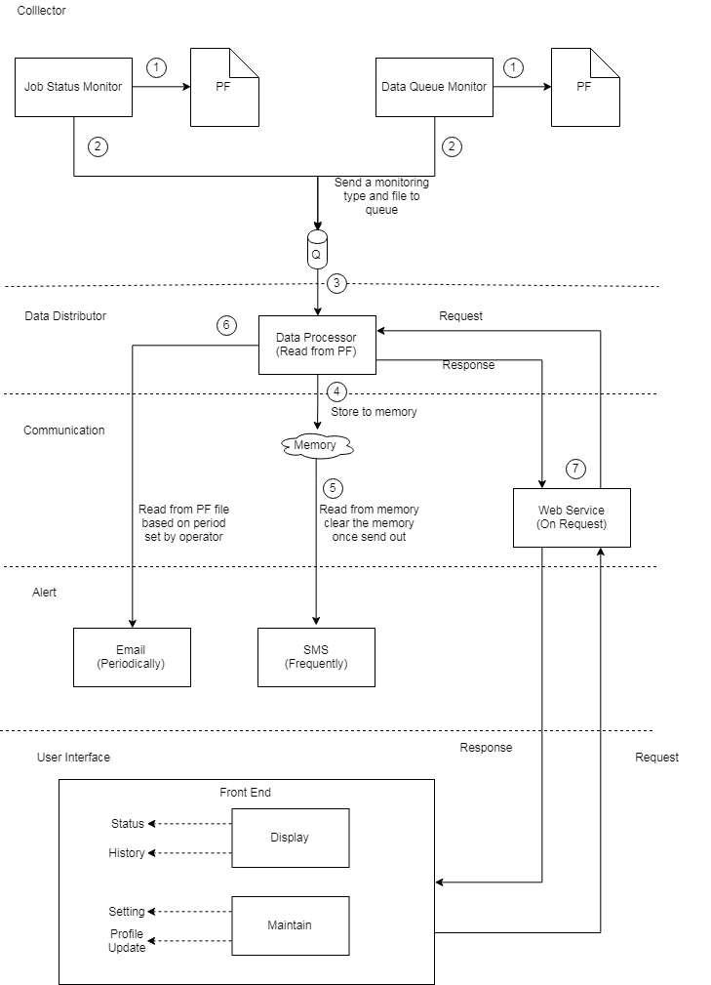

**Description:**

1. Job and Data Queue Monitoring write to each PF files.
2. Job and Data Queue Monitoring send a queue message with type and PF name to queue.
3. Data Processor pick up message and get the unprocessed data from specific PF files.
4. Data Processor store the data in memory temporary.
5. SMS thread always check the memory if there has any data ready to send out.
6. Email thread read from PF files based on the period set by operator.
7. Web service triggered from front end to display data on screen or maintain the operator profile, email/sms sleep time, monitoring program parameter.